**UK Road Safety: Traffic Accidents Report**

**Context**

The dataset used to prepare this report comes from the Open Data website of the UK government, where they have been published by the Department of Transport. It contains significant information about traffic accidents in the UK; mainly, geographical locations of accidents, weather conditions, type of vehicles, number of casualties, age bands, vehicle maneuvers and other data related to traffic accidents.

The dataset comprises of two csv files:

**AccidentInformation.csv**: every line in the file represents a unique traffic accident, featuring various properties related to the accident as columns.

**Vehicle_Information.csv**: every line in the file represents the involvement of a unique vehicle in a unique traffic accident, featuring various vehicle and passenger properties as columns.

**Analysis and Findings:**

The data shows that there is an increase in number of traffic accidents with the period of 2010 and 2016. Evidently, this is proportional to the increase of traffic volume over time. The total number of accidents in 2010 were 106,701, however in 2016 it is as high as 117,474. Clearly, the number of fatal accidents also increased over time from 1193 in 2010 to 1480 in 2016. The same increasing trend is observed in number of serious accidents from 13,195 to 18,177 in six years’ time. Although during 2012 and 2013 the number of accidents seem to have dropped, the positive trend is reversed in 2014.

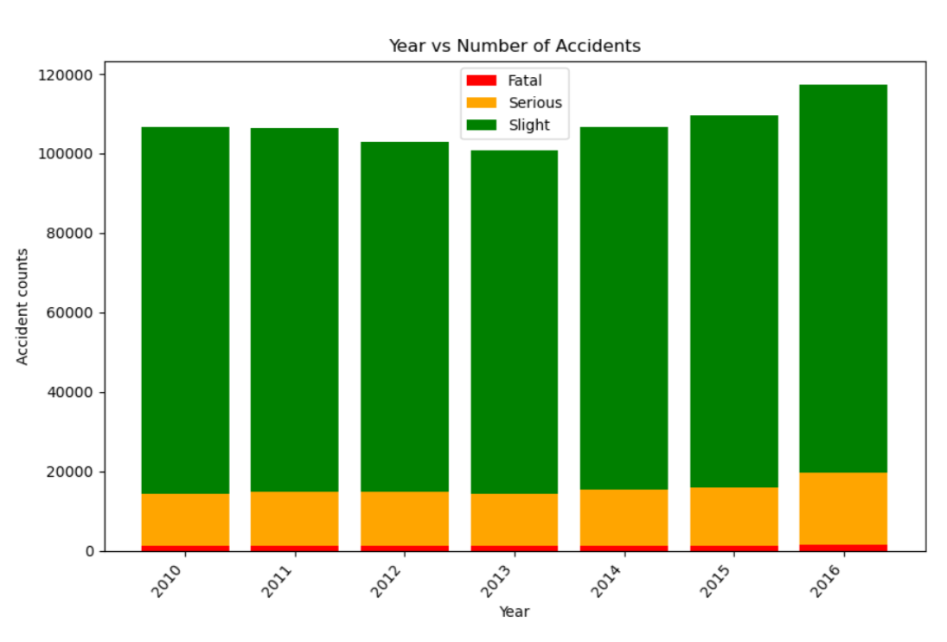

The dataset categorizes the accident severity levels by slight, serious and fatal. According to the data, majority of traffic accidents that occurred between 2010 and 2016 are slight (86%), while around 12% of accidents are serious and 1% is fatal.

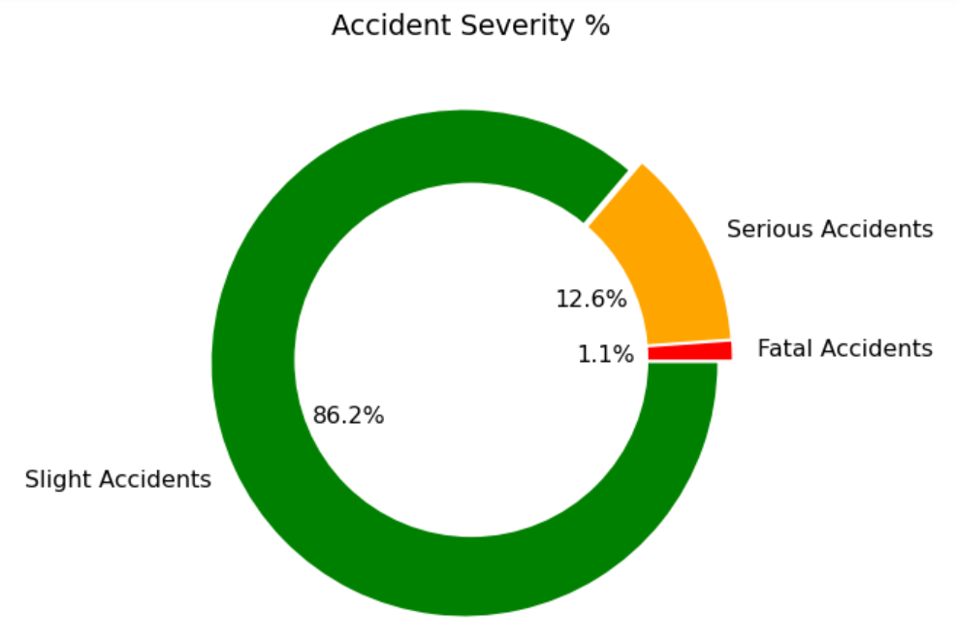

In order to identify the locations of main traffic accidents, a google maps plot was created with a heatmap layer based on just the locations. The plot indicates that from 2010-2016 almost the entirety of Birmingham has had accidents and indicates a greater number of accidents happen in the areas closer to the city center.

This is likely due to the traffic concentration increasing around the city center and from other plots it was determined that rush hour traffic increases the number of accidents. As the city center is the central hub for business in Birmingham this means the traffic concentration around the city center would be very high during commuting hours.

The accident locations heatmap was repeated, however this time the Accident Severities were added as weights. Again, the map seems to indicate more serious and fatal accidents were concentrated in the city center. However, this could be just a repeat of the concentrations of accidents further enhanced by the severity.

The following plots show all of the accidents in the filtered data set (years from 2010-2016) and therefore covers most of the United Kingdom. It is evident that most of the accidents are concentrated in Large Cities and Towns (Urban areas) where there is a large population and therefore concentration of traffic, which would have led to a greater number of accidents.

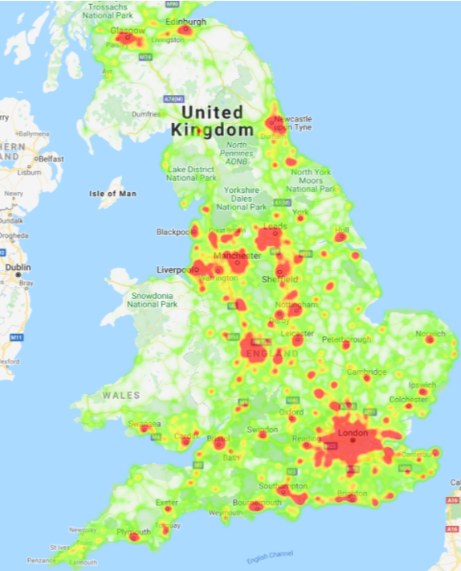

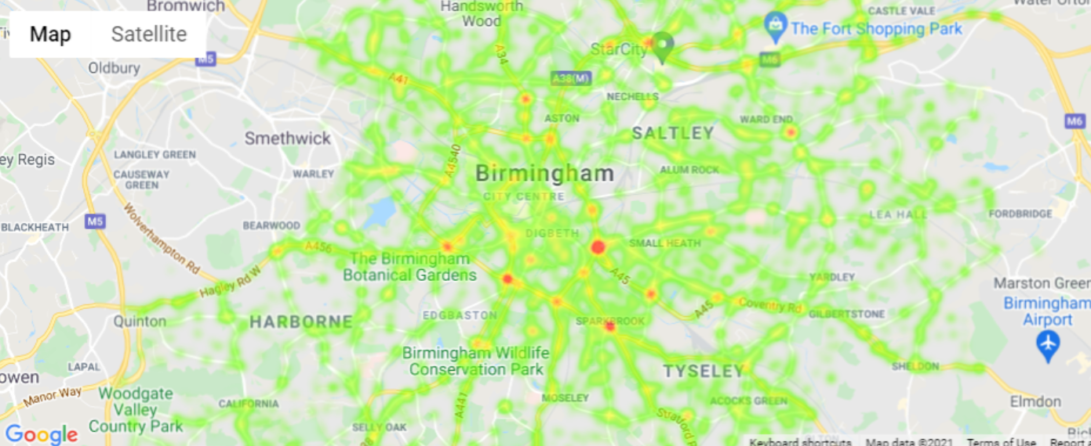

During the period from 2010 to 2016 the age group involved in most accidents was 25-35 year olds. Unfortunately, there is not enough data to show what proportion of driving is done by that age group compared to others so this limits the certainty of this conclusion. The severity of accidents is similar for most age groups, although it does appear that in the over 75 age group, there is a higher proportion of ‘Slight’ accidents.

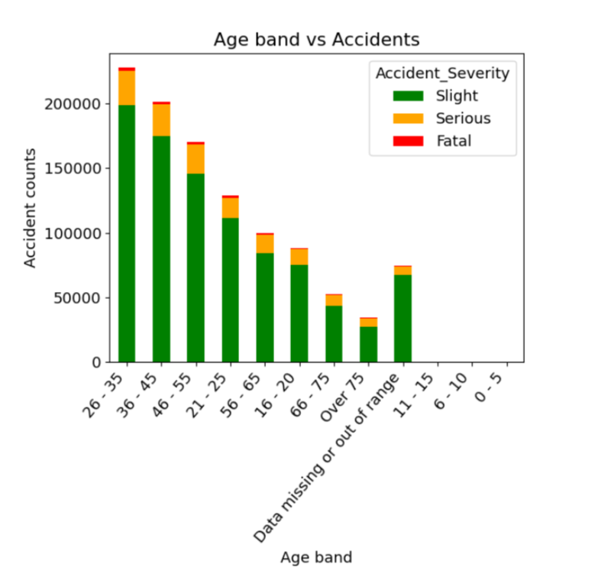

During the period from 2010 to 2016 within the working week the number of accidents gradually increases from Monday with a significant increase on a Friday. The number reduces on Saturday and again on Sunday. The severity of accidents remains similar on each day. This may simply be related to the volume of traffic on the roads.

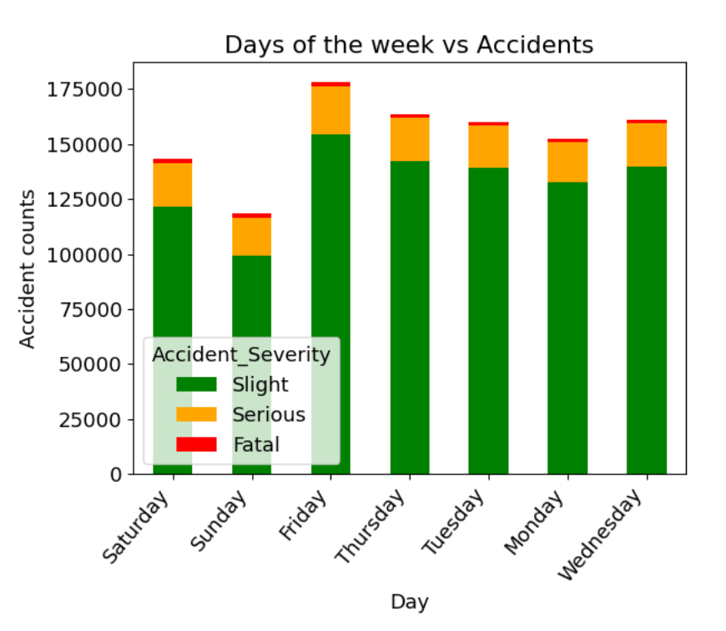

During the period from 2010 to 2016 men were named as driver in just over 60% of accidents whilst women were named as driver in 36%. It is not straightforward to draw a firm conclusion without the knowledge of how traffic volume is split between gender. Nevertheless, according to available data, it is reasonable to suggest that women are safer drivers than men.

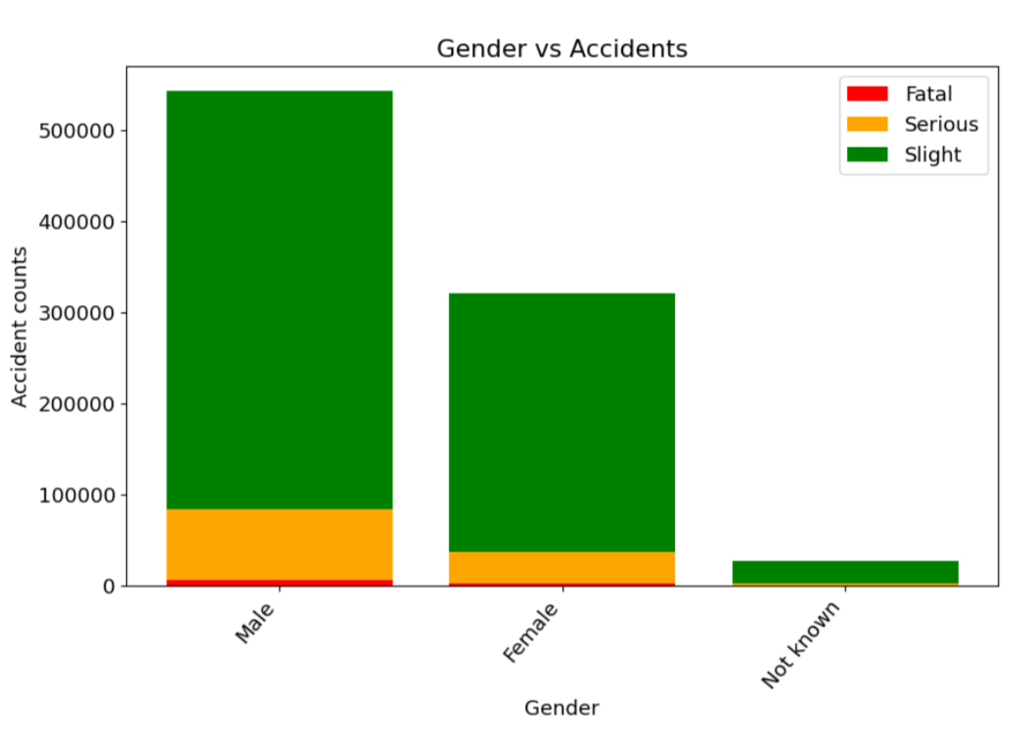

During the period from 2010 to 2016 there were significantly more accidents where there is no junction within 20 meters. These accidents are more serious and unfortunately more are fatal. This may be due to the higher speed that vehicles travel on the ‘open road’. It is also significant that many accidents happen when approaching or navigating a junction or roundabout whereas ‘slip road’s’ appear to be safer.

